The Inter-Faith Chapel
“A House of Prayer for All People”

3680 South Leisure World Blvd.
Silver Spring, Maryland 20906

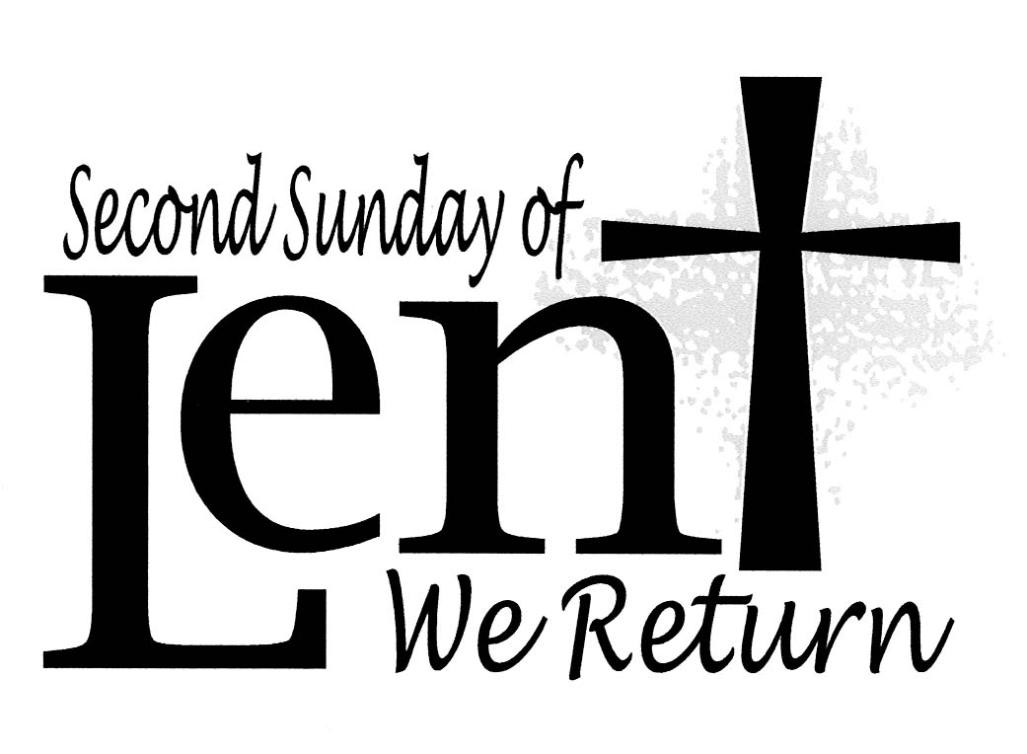

March 8, 2020
Second Sunday in Lent
10:00 AM Worship Service ________

 As you enter to worship, please remember to silence your cell phones. 

SILENT MEDITATION

Tender God, receive us, hear us, open us, and use us in the dark night of our lives. Gracious God, receive us, hear us, open us, and use us in the bright days of our lives… as only you can do. - A Collection of Prayers for Healing

WORDS OF WELCOME Dr. Ramonia Lee

LIGHTING THE PEACE CANDLE

We light this candle as a symbol of our ongoing commitment to peace in our world.

PRELUDE Lift High the Cross Arr. Donald Busarow
Kevin M. Clemens, Director of Music

CALL TO WORSHIP

Leader: Welcome to this second step on our Lenten journey.
PEOPLE: We come with great hope and expectation.

Leader: We come this day seeking to encounter Christ.
PEOPLE: We come with concerns and questions that only He can answer.

Leader: Let us step forward boldly, listening for God’s call in our lives.
PEOPLE: It moves us, challenges us, and changes us.

Leader: Our Lenten journey will demand much of us.
PEOPLE: Our Lenten journey will move us even into the shadows of night.

ALL: Let us place our trust in God always.
Lord, guide our lives and our moves, we pray. Amen.

INVOCATION

 HYMN Lift High the Cross

 You May Stand
Music used by permission, CCLI #168324

CALL TO CONFESSION

KYRIE

PRAYER OF CONFESSION UNISON

Lord, we are stubborn people. We want to know all the answers, but we are nervous about seeking them in new places. We want to trust you, but when you call us to a new land and a new birth, our feet and spirits hesitate. Forgive us if we have become stagnant in our spiritual lives. Forgive our becoming comfortable with comfort. Forgive our fear and open us to new ways, new ideas, and new life offered each day through Jesus Christ. Amen.

WORDS OF ASSURANCE

 AN AFFIRMATION OF FAITH

We believe in God,
Infinite in love,
Supreme in wisdom,
Unlimited in power,
And whose wonder and glory prevail over all things.

We believe in Jesus the Christ,
The gift of God’s immeasurable love,
The expression of God’s unfailing grace,
The fulfillment of hope,
And the promise of our deliverance.

We believe in the Holy Spirit,
God’s Presence with us,
Revealed through the Word,
Found in our hearts,
And fulfilled in the community of the church as the Body of Christ.

Therefore, we devote ourselves to seeking Jesus,
Through lives of daily prayer, study, service and reflection,
And putting our trust in Him,
For the sake of the transformation of the world. Amen.

 GLORIA PATRI

Glory be to the Father, and to the Son, and to the Holy Ghost;
As it was in the beginning, is now, and ever shall be,
World without end. Amen. Amen.

SACRAMENT OF BAPTISM

Brooklyn Elizabeth Norton

Covenant with the Family

- Do you desire to have your child baptized into the faith and family of Jesus Christ?

- Will you foster for your child an appreciation for the life and teachings of Jesus?

- Will you so fashion your lives that your child may come to honor the role that faith may have in her life?

- Will you journey with your child to discover the wonder of God's love made manifest here this day?

Covenant with the Family of Faith

- Do you, the congregation of The Inter-Faith Chapel, on behalf of the universal church and the great family of faith, covenant with this family to offer them your support, care, and love for the strengthening of their life together?

PRAYER OF CELEBRATION AND DEDICATION UNISON

Gracious God of Life, we rejoice together in the gift of Christ, who gives us new life daily. We give you thanks for the grace acknowledged here today in water and the Holy Spirit. Today, we celebrate the baptism of Brooklyn. Keep her always in the faith and communion of your church, we pray. Today, we recommit ourselves to our own baptism vows. Help us always to remain in the covenant to nurture one another and to seek to be a community of love and care for all. Today, we welcome Brooklyn into the family of Christ. Thanks be to God. Amen.

SCRIPTURE READING Psalm 121 OT 702

Reader: Nancy Czujko

ANTHEM Jesu, Grant Me This I Pray C. H. Kitson
Chancel Choir

MORNING PRAYER

LORD’S PRAYER UNISON

Our Father who art in heaven, hallowed be thy name. Thy kingdom come, thy will be done, on earth as it is in heaven. Give us this day our daily bread. And forgive us our sins as we forgive those who sin against us. And lead us not into temptation, but deliver us from evil. For thine is the kingdom, and the power and the glory, forever. Amen.

SCRIPTURE READING John 3: 1-17 NT 114

HYMN Wash, O God, Our Sons and Daughters

SERMON “A Busy Night” Dr. Woodie Rea

INVITATION TO OFFERING

OFFERTORY God So Loved the World John Stainer

Chancel Choir

DOXOLOGY (Tune: Old Hundredth)
Praise God, from whom all blessings flow;
Praise Him, all creatures here below;
Praise Him above, ye heavenly host;
Praise Father, Son, and Holy Ghost. Amen.

 PRAYER OF DEDICATION

 PASSING OF THE PEACE

During this increased cold and flu season, please consider making a prayer gesture with your hands, and greeting your neighbor verbally.

 CLOSING HYMN Blessed Assurance

 BENEDICTION RESPONSIVE

Leader: As we leave this community of the spirit,
May we walk through darkness ever toward the Light.

PEOPLE: May we go forth,
In the certainty of faith,
In the knowledge of love,
And with the vision of hope.

Leader: And in our going, may we be blessed with all good things,
On this day, and forevermore. Amen.

 BENEDICTION RESPONSE Tune: Ar Hyd Y Nos

“Go, my children, with my blessing, never alone.
Waking, sleeping, I am with you, you are my own.
In my love’s baptismal river I have made you mine forever.
Go, my children, with my blessing, you are my own.”

POSTLUDE Chaconne Louis Couperin

Kevin M. Clemens, Director of Music

PARTING THOUGHT

May you move through this day with joy, gratitude, and peace. May the light shine brightly in your night, and may love be manifest in many slight and subtle ways.

– Frederic and Mary Ann Brussat

Welcome To The Inter-Faith Chapel

We are committed to being “A House of Prayer for All People.”

We are delighted you are here today, and hope you will return often!

We are seeking to share the love of God through caring, outreach, study, and worship. We invite you to share with us in this journey.

Believing in God whose love and grace are accessible to all,
we strive to make our worship service accessible to all.

For V isually I mpaired Large Print Bibles are available
For H earing I mpaired Sound Enhancement Headphones
For P hysically I mpaired Wheelchair Accessible Seating

Automated Doors are available at front and side entrances

If you need any assistance during the worship service, please ask an usher.

ALTAR FLOWERS Dedicated by Jim McAlister in memory of his wife
LaRene on her March 3 birthday

USHERS John Moens, Head Usher
Arlene Kaiser, Bertha Knisely, Marlys Moholt

GREETER Lynne Butler

FLOWER MAKERS Maggi Lindley and Anne Matthews

Delivery of Altar Flowers on Monday, March 9

Heidi Bender  Diane Gibbs

Presence on Sunday, March 1
202
March 1 Offering  $11,296 | Weekly Budget  $8,462
Year to Date Offering  $70,263 | Year to Date Budget  $76,158

ANNOUNCEMENTS & OPPORTUNITIES

VISITOR / NEW MEMBER REGISTER If you are visiting with us today, we extend a special welcome to you and are so pleased you chose to worship with us. Please sign the Visitor Register located in the narthex and pick up an Inter-Faith Chapel coffee mug as our small gift of welcome and appreciation. Also, if you are looking for a church home and would like to learn more about this vibrant and active congregation, please let us know by signing the Member / Affiliate Register. We are glad you are with us today and hope you will come back soon!

LINGER LONGER Join us in the Fellowship Hall immediately following our worship service for an extended time of fellowship. Our “Linger Longer” provides an opportunity to spend time with one another while enjoying a cup of coffee/tea and a light snack. We are in need of volunteers to help host this time of fellowship. Responsibilities include setting up simple snacks and clean-up afterwards. If you would be willing to be a host for one Sunday, please sign up on the clipboard in the Narthex or call The Chapel Office at 301-598-5312.

MID-WEEK LENTEN WORSHIP You are invited to join us on Wednesdays during Lent until April 1 for worship, followed by the “Our Soup, Your Sandwich” Lenten luncheon in the Fellowship Hall. Each service will focus on one of the aspects of The Sermon on The Mount from the Gospel of Matthew. An organ prelude will begin at 11:45 am each week, followed by the service at 12 noon.

LENTEN STUDY During the season of Lent, we will study the book Sermon on the Mount by Carol Geisler. Dr. Rea and Dr. Lee will lead the study which will meet on Tuesdays during Lent: March 3 – March 31 at 10:30 am. To register, call 301-598-5312 or go to www.inter-faithchapel.org.

CENTERING PRAYER: A LENTEN PRACTICE In Psalm 46:10 we hear the invitation to “Be still and know that I am God.” Centering Prayer is a method of praying used by Christians placing a strong emphasis on interior silence. During the Lenten season, you are invited to join us in the Meditation Chapel on Monday mornings through Monday, April 6th from 10:00 – 11:00 am to learn and practice the art of being present to God through centering prayer. These sessions will be led by Bertie Knisely, a Certified Spiritual Director.

CHAIR YOGA CLASS CONTINUES Chapel member Christine Tetrault is continuing the free Body and Brain Chair Yoga class on Friday, March 6, 13 and 27 from 11:00 am – 11:45 am. The class focuses on gentle movements that make fewer demands on balance and strength. A few slots are available for new participants. Please call 301-598-5312 to be added to the class.

TAIZÉ WORSHIP SERVICE Join us on Sunday, March 15 at 4:00 pm for a candlelight Taizé worship service. Taizé worship, which takes its name from a small community in France, is contemplative in nature. Repetitive sung prayers, silent meditation, scripture readings, and common prayer are all integral aspects of Taizé worship. Come join us for a new and meaningful worship experience.

EASTER FLOWERS Beautiful Easter lilies, white mums, and pink hydrangeas will adorn the Sanctuary as we celebrate our Lord Jesus Christ’s resurrection on Easter Sunday, April 12. Would you like to dedicate flowers in honor or in memory of a loved one? Please pick up an order form in the Narthex and return it to the church office with your payment, no later than April 1. You may also order at www.inter-faithchapel.org
The Easter plant that you order is yours to take home following the second service on Easter Sunday!

HOLY WEEK MOVIE On Wednesday of Holy Week, April 8 at 1:00 pm join us for a viewing of King of Kings in the Fellowship Hall.

This film has a PG-13 rating for its depiction of the reality of crucifixion and violence between the crowd and soldiers. The film will be shown in the Fellowship Hall. All are welcome and there is no need for reservations. The movie’s running time is 168 minutes.

BOOK CLUB: DEAR EDWARD The Book Club will gather on Friday, April 24 at 2:00 pm to discuss Dear Edward by Ann Napolitano. No RSVPs are necessary.

SHEPHERD’S TABLE PANTRY ITEM DONATIONS Pantry items may be brought to the Chapel on Sundays, March 8 and 15, or on weekdays, March 9 through March 19 from 9:30 a.m. to 2:30 p.m. Bins/boxes will be available in the Narthex for your pantry item donations. Examples of non-perishable pantry items include: canned vegetables, hot sauce, coffee, powdered coffee creamer, sugar, artificial sweeteners, salad dressings, broths (vegetable, chicken, beef), cereals, wheat pasta, brown rice, quinoa, lentils, dry beans, and spices (salt, pepper, onion powder, garlic powder, Italian seasoning). Please check expiration dates before donating. Thank you for your continuing support!

In Memoriam

Jean Strahan
November 1, 1926 – March 1, 2020

CHAPEL CALENDAR
Monday, March 9 10:00 AM Centering Prayer
2:00 PM Sandwich Makers

Tuesday, March 10 10:00 AM Men’s Chorale
10:30 AM Lenten Bible Study
10:30 AM Brooke Grove Service
12:00 PM Staff Meeting
1:30 PM Handbells

Wednesday, March 11 10:00 AM Committee for the
Homeless and Working Poor
10:30 AM Women’s Chorus
12:00 PM Lenten Service 12:45 PM Our Soup, Your Sandwich
Lunch
3:00 PM Alzheimer’s Support

Thursday, March 12 9:30 AM Finance Committee
2:00 PM Primetimers Choir
4:00 PM Dance Practice
7:00 PM Chancel Choir

Friday, March 13 10:00 AM Knitting Group
11:00 AM Yoga

THE INTER-FAITH CHAPEL

3680 South Leisure World Blvd.
Silver Spring, MD 20906
www.inter-faithchapel.org

CHAPEL OFFICE HOURS

9:00 AM - 3:00 PM  Monday – Friday
301-598-5312

Rev. Dr. Woodie Rea, Senior Minister
Rev. Dr. Ramonia Lee, Minister of Congregational Life
Kevin M. Clemens, Director of Music
Bonnie Bonner, Administrator
Joy Dufour, Administrative Assistant
Steve Buck, Gary Carpenter, Video Technicians and Sexton

