**The Inter-Faith Chapel**

**“A House of Prayer for All People”**

**3680 South Leisure World Blvd.**

**Silver Spring, Maryland 20906**

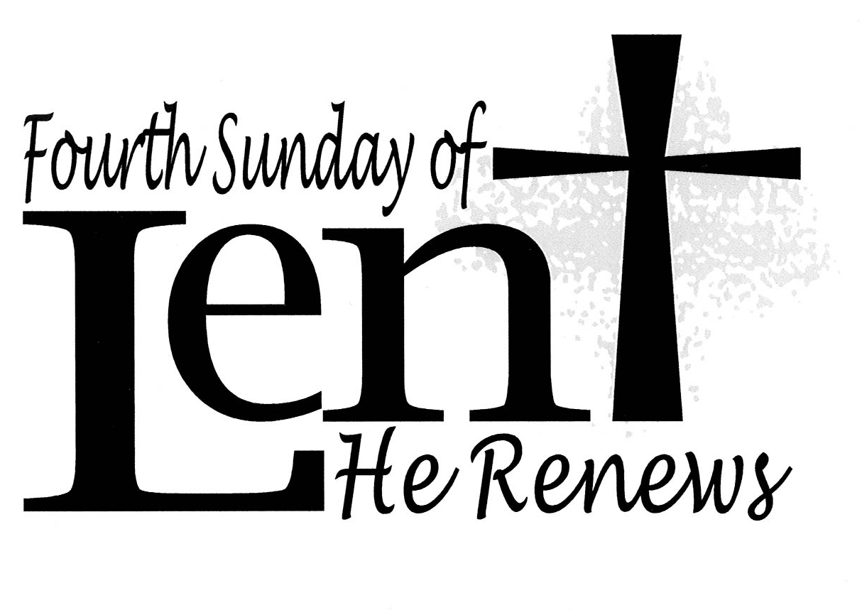

**March 1, 2020**

**First Sunday in Lent**

**Holy Communion**

**10:00 AM Worship Service ­­­________**

** *As you enter to worship, please remember to silence your cell phones.* **

**SILENT MEDITATION**

*As we take this journey of Lent, may God walk with us, sustain us, and nurture us. As we go through the wilderness and the temptations of life, may God give us wisdom, strength, a focused perspective, and an open heart.*

**WORDS OF WELCOME Dr. Ramonia L. Lee**

**LIGHTING THE PEACE CANDLE**

**We light this candle as a symbol of our ongoing commitment to *peace* in our world.**

**PRELUDE *Prelude on “Ebenezer”* Richard Purvis**

**Kevin M. Clemens, Director of Music**

**CALL TO WORSHIP**

*Leader: The season of Lent sets us on a journey.*

**PEOPLE: The journey begins in the wilderness.**

*Leader: We follow the way of Jesus who faced*

*trials, trouble, temptation, and testing.*

**PEOPLE: Like Jesus, we are not alone,**

**The Holy Spirit is with us and directs us.**

*Leader: Our call is to trust in God and to do God’s will in all things.*

**PEOPLE: For God leads us not only *into* the wilderness,**

**but also *through* the wilderness.**

**ALL: Let us worship God,**

**Our refuge and fortress, our shelter and our strength.**

**INVOCATION**

** HYMN *Jesus, Tempted in the Desert***

 You may stand.

*Music used by permission, CCLI #168324*

**CALL TO CONFESSION**

**KYRIE**

**PRAYER OF CONFESSION** **UNISON**

**God, the distractions and temptations of our world are all around us. We are diverted and need focus, enticed and need self-control, frustrated and need calmness, anxious and need peace. Instead of following where you lead, O God, at times we follow others who show us a vision that entices and often deceives us from true happiness and worth. Forgive us for our distractions that rob us from the full life that is promised with you. Continue to be with us, O Lord, as we journey through Lent with you. Amen.**

**WORDS OF ASSURANCE AND PARDON**

** AFFIRMATION OF FAITH**

*Leader:*

*Let us stand as we are able, and affirm our faith.*

**PEOPLE:**

**We believe in God,**

**Creator of all that is, and all that shall be,**

**Redeemer of all that is less than it could be,**

**Sustainer of our living, our loving, our being.**

**We believe that Jesus Christ lived without sin, though he endured all the common trials and temptations of human life.**

**We believe that in the pain suffered by Christ, all our hurts, torments, and betrayals were embraced in the purity of sacrificing love.**

**We believe in the presence of the Holy Spirit, found in the hearts of all who have a passion for peace, love, hope, and joy.**

**We believe in the Gospel; the good news offered to us in Jesus.**

**Often misunderstood by the world, but leading us in the way of life. Amen.**

** GLORIA PATRI**

**Glory be to the Father, and to the Son, and to the Holy Ghost;**

**As it was in the beginning, is now, and ever shall be,**

**World without end. Amen. Amen.**

**ANTHEM *I Want Jesus to Walk with Me* Arr. by Raymond Hann**

**Chancel Choir**

**SCRIPTURE READING Matthew 4: 1-11 NT 3**

**Reader: Marian Cain-Hayden**

**SERMON “The Temptations” Dr. Woodie Rea**

**INVITATION TO THE OFFERING**

**OFFERTORY *O, My God, Bestow Thy Tender Mercy*  Pergolesi / Hopson**

**Chancel Choir**

** DOXOLOGY (Tune: Old Hundredth)**

**Praise God from whom all blessings flow;**

**Praise Him, all creatures here below;**

**Praise Him above, ye heavenly host:**

**Praise Father, Son, and Holy Ghost. Amen.**

** PRAYER OF DEDICATION**

**COMMUNION HYMN  *Bread of the World, in Mercy Broken***

**INVITATION TO HOLY COMMUNION**

**WORDS OF PREPARATION**

*Leader: Through Jesus, we confirm that God loves us and welcomes us.*

**PEOPLE: Through Jesus, we believe that God is faithful and true.**

*Leader: Let us come to this table, not because we must, but because we may;*

**PEOPLE: Let us sit together in humility and harmony,**

**rather than in pride or possessiveness.**

*Leader: Let us come, not that we are strong, but that we are needy; not that we have any claim on Christ, but that he invites us to receive his grace and experience his presence.*

**PEOPLE: Let us partake of this meal, that The Christ may be made known to us in the breaking of the bread and the sharing of the cup.**

**COMMUNION PRAYER UNISON**

**With thanksgiving, we take this bread and this cup and proclaim the grace of Jesus’ life, and the great mystery of the resurrection of our Lord. Send us your Holy Spirit, that this meal may be holy and that we may become one. Unite us in faith, inspire us to love, encourage us with hope, that we may receive Christ who is revealed to us in this holy banquet. Hear us as we continue to pray…**

**THE LORD’S PRAYER SUNG BY ALL**

**Our Father who art in heaven, hallowed be thy name, thy kingdom come, thy will be done on earth as it is in heaven. Give us this day our daily bread; and forgive us our debts as we forgive our debtors. And lead us not into temptation, but deliver us from evil, for thine is the kingdom, and the power and the glory forever. Amen.**

**THE WORDS OF INSTITUTION**

**SHARING THE BREAD AND CUP**

**PRAYER AFTER COMMUNION UNISON**

**Almighty God, we give you thanks that you have refreshed us at your table through the experience of the real presence of Christ. And now, strengthen our faith in you, increase our love for one another, and expand our appreciation for all that is good and beautiful in our world. Through Christ we pray. Amen.**

** PASSING THE PEACE**

*During the Passing the Peace, throughout the cold and flu season,*

*we offer you the option to greet your neighbor verbally.*

** HYMN *Jesus Walked This Lonesome Valley***

** BENEDICTION RESPONSE Tune: Ar Hyd Y Nos**

**“Go, my children, with my blessing, never alone.**

**Waking, sleeping, I am with you, you are my own.**

**In my love’s baptismal river I have made you mine forever**.

**Go, my children, with my blessing, you are my own.”**

**POSTLUDE *Nachspiel* Hermann Schroeder**

**Kevin Clemens, Organist**

**A PARTING THOUGHT**

*In the stillness of this breath, I can take comfort in knowing that I am part of One greater than myself. -* Joan Noeldechen in *Pocket Prayers*

**HOLY COMMUNION** is provided two different ways at The Inter-Faith Chapel.

You are invited to participate in the form most familiar and comfortable to you.

 **COMMUNION is served in the PEWS** on the

LEFT SIDE of the sanctuary facing the cross.

Wafers and individual ***grape juice*** cups will be passed

in trays among the congregation.

**COMMUNION is served by INTINCTION** on the

RIGHT SIDE of the sanctuary facing the cross.

Communicants will come forward down the center aisle

and receive a wafer to dip in the chalice of ***wine***.

**GLUTEN-FREE COMMUNION** is available from the minister at the altar table, or in the pew upon request.

**COMMUNION STEWARDS**

**Clydis Kellough and Millie Spencer**

**COMMUNION ASSISTANT**

**Naomi Rogers**

**CHOIR COMMUNION SERVERS**

**Maureen Harris and Nancy Czujko**

**SERVING COMMUNION IN THE PEWS**

**Tronette Anochie, Betty Hughes**

**Anne Matthews, Claudette Warner-Milne**

**Welcome To The Inter-Faith Chapel**

**We are committed to being “*A House of Prayer for All People*.”**

**We are seeking to share the Love of God through caring, outreach, study, and worship. We invite you to share with us in this journey.**

**We are delighted you are here today, and hope you will return soon**

**and often!**

**Believing in God whose love and grace are accessible to all,**

**we strive to make our worship service accessible to all.**

***For V isually I mpaired Large Print Bibles are available***

*****For H earing I mpaired Sound Enhancement Headphones***

***For P hysically I mpaired Wheelchair Accessible Seating***

***Automated Doors are available at front and side entrances***

**If you need any assistance during the worship service, please ask an usher.**

**ALTAR FLOWERS Dedicated by Bill Hahn in memory of his wife Edna**

**on her March 4 birthday**

**USHERS Clydis Kellough, Head Usher**

**Cloteele Damsky, Lois Smith, Raymond Williams**

**GREETER Juanita Sealy-Williams**

**FLOWER MAKERS Maggi Lindley and Marlys Moholt**

**Delivery of Altar Flowers on Monday, March 2**

**Beryl Adams  Heidi Bender**

**Presence on Sunday, February 23**

**186**

|  |  |
| --- | --- |
| **February 23 Offering**  **$4,953** | **Weekly Budget**  **$8,462** |
| **Year to Date Offering**  **$58,967** | **Year to Date Budget**  **$67,696** |

***ANNOUNCEMENTS & OPPORTUNITIES***

**VISITOR / NEW MEMBER REGISTER**  If you are visiting with us today, we extend a special welcome to you and are so pleased you chose to worship with us. Please sign the *Visitor Register* located in the narthex and pick up an Inter-Faith Chapel coffee mug as our small gift of welcome and appreciation. Also, if you are looking for a church home and would like to learn more about this vibrant and active congregation, please let us know by signing the *Member / Affiliate Register*. We are glad you are with us today and hope you will come back soon!

**LINGER LONGER** Join us in the Fellowship Hall immediately following our worship service for an extended time of fellowship. Our “Linger Longer” provides an opportunity to spend time with one another while enjoying a cup of coffee/tea and a light snack. We are in need of volunteers to help host this time of fellowship. Responsibilities include setting up simple snacks and clean-up afterwards. If you would be willing to be a host for one Sunday, please sign up on the clipboard in the Narthex or call The Chapel Office at 301-598-5312.

**MID-WEEK LENTEN WORSHIP** You are invited to join us on Wednesdays during Lent (from March 4 – April 1) for worship, followed by the “Our Soup, Your Sandwich” Lenten luncheon in the Fellowship Hall. Each service will focus on one of the aspects of *The Sermon on The Mount* from the Gospel of Matthew. An organ prelude will begin at 11:45 am each week, followed by the service at 12 noon.

**LENTEN STUDY** During the season of Lent, we will study the book *Sermon on the Mount* by Carol Geisler. Dr. Rea and Dr. Lee will lead the study which will meet on **Tuesdays** during Lent: **March 3 – March 31** at 10:30 am. To register, call 301-598-5312 or go to [www.inter-faithchapel.org](http://www.inter-faithchapel.org).

**CENTERING PRAYER: A LENTEN PRACTICE** In Psalm 46:10 we hear the invitation to “Be still and know that I am God.” During the Lenten season you are invited to gather as we seek to be present to God and to give ourselves to God in love through the practice of centering prayer. Participants will meet Monday mornings from 10:00 – 11:00 am in the Meditation Chapel, beginning **Monday, March 2** **through** **Monday, April 6**.

**CHAIR YOGA CLASS CONTINUES** Chapel member Christine Tetrault is continuing the free Body and Brain Chair Yoga class on Friday, March 6, 13 and 27 from 11:00 am – 11:45 am. The class focuses on gentle movements that make fewer demands on balance and strength. A few slots are available for new participants. Please call 301-598-5312 to be added to the class.

**TAIZÉ WORSHIP SERVICE** Join us on **Sunday, March 15 at 4:00 pm** for a candlelight Taizé worship service. Taizé worship, which takes its name from a small community in France, is contemplative in nature. Repetitive sung prayers, silent meditation, scripture readings, and common prayer are all integral aspects of Taizé worship. Come join us for a new and meaningful worship experience.

**DAYLIGHT SAVING TIME BEGINS** Remember to ‘Spring forward’. Set your clocks an hour ahead on **March 8, 2020** at 2:00 AM.

**EASTER FLOWERS** Beautiful Easter lilies, white mums, and pink hydrangeas will adorn the Sanctuary as we celebrate our Lord Jesus Christ’s resurrection on Easter Sunday, April 12. Would you like to dedicate flowers in honor or in memory of a loved one? There are two ways you may order flowers. You may pick up an order form in the Narthex and return it to the church office with your payment, no later than **April 1**. You may also order at [www.inter-faithchapel.org](http://www.inter-faithchapel.org) no later than April 1. Order early as supplies are limited. Please do not put the order form or your payment in the offering plate. You may take home your Easter plant after the 11:00 am service on Easter Sunday, April 12 or pick it up on Tuesday, April 14 between 9:00 am and 3:00 pm.

**HOLY WEEK MOVIE** On Wednesday of Holy Week, **April 8** at 1:00 pm join us for a viewing of ***King of Kings*** in the Fellowship Hall.

**BOOK CLUB: *DEAR EDWARD*** The Book Club will gather on **Friday, April 24** at 2:00 pm to discuss *Dear Edward* by Ann Napolitano. No RSVPs are necessary.

This film has a PG-13 rating for its depiction of the reality of crucifixion and violence between the crowd and soldiers. The film will be shown in the Fellowship Hall. All are welcome and there is no need for reservations. The movie’s running time is 168 minutes.

**FLOWER DELIVERY** We arein need of a few more volunteers for March flower delivery. Please check the signup clipboard in the Narthex to volunteer to deliver flowers to brighten someone’s day.

**SHEPHERD’S TABLE PANTRY ITEM DONATIONS** Pantry items may be brought to the Chapel on Sundays, March 8 and 15, or on weekdays, **March 9 through March 19** from 9:30 a.m. to 2:30 p.m. Bins/boxes will be available in the Narthex for your pantry item donations. Examples of non-perishable pantry items include: canned vegetables, hot sauce, coffee, powdered coffee creamer, sugar, artificial sweeteners, salad dressings, broths (*vegetable, chicken, beef*), cereals, wheat pasta, brown rice, quinoa, lentils, dry beans, and spices (*salt, pepper, onion powder, garlic powder, Italian seasoning*). *Please check expiration dates before donating.* **Thank you for your continuing support!**

**CHAPEL CALENDAR**

**Monday, March 2 10:00 PM Centering Prayer**

**2:00 PM Sandwich Makers**

**Tuesday, March 3 10:00 AM Men’s Chorale**

**10:30 AM Lenten Bible Study**

**12:00 PM Staff**

**1:30 PM Handbells**

**Wednesday, March 4 10:30 AM Women’s Chorus**

**12:00 PM Lenten Service**

**12:45 PM Our Soup, Your Sandwich**

**3:00 PM Alzheimer’s Support**

**Thursday, March 5 2:00 PM Primetimers Choir**

**4:00 PM Dance Practice**

**7:00 PM Chancel Choir**

**Friday, March 6 11:00 AM Yoga (for those who**

**registered)**

**7:00 PM JRLW Shabbat**

**THE INTER-FAITH CHAPEL**

**3680 South Leisure World Blvd.**

**Silver Spring, MD 20906**

[**www.inter-faithchapel.org**](http://www.inter-faithchapel.org)

**CHAPEL OFFICE HOURS**

**9:00 AM - 3:00 PM  Monday – Friday**

**301-598-5312**

***Rev. Dr. Woodie Rea, Senior Minister***

***Rev. Dr. Ramonia Lee, Minister of Congregational Life***

***Kevin M. Clemens, Director of Music***

***Bonnie Bonner, Administrator***

***Joy Dufour, Administrative Assistant***

***Steve Buck, Gary Carpenter, Video Technicians and Sexton***